Web development[WEDE5020]

Name: Solomzi Eugene Skolo
Student Number:ST10543378

Contents
No table of contents entries found.

1.Organisation Overview
KELLY’S DELIGHT BAKERY
Kelly’s Delight Bakery was founded in 2022 by Kelly Mthembu that specializes in baking cakes, bread, muffins and scones that are very affordable

- Vision Statement
- Become the most trusted and well-known bakery for producing quality and fresh products

- Mission Statement
- Provide fresh and affordable baked goods to customers.

- Target Audience
- Families, students, and anyone who is looking for fresh baked products

2.Website Goals and objectives
- Website goals
- Raise awareness of the business
- Show the bakery products and their prices
- Enable customers to order online
- Provide business contact

- Key Performance Indicators
- Number of online orders will increase
- Rise in a number of website visitors

3. Proposed Website Features and Functionality
- Homepage
- Welcome section
- Website features products and special offers
- About us
- Background of the business, the mission, vision.
- Products
- Fresh Cakes, bread, muffins, and scones, including product prices.
- Contact us
- Physical address, contact number, email address, forms for enquires.

4. Design and user experience
- Overall layout and design
- A nice and simple layout that includes the navigation menu at the top, pictures that represent the products that sold and also include accessible buttons such as, “Place Order” and “Reach out”

- Colour Scheme
- Cream
- Light Brown
- Pastel Pink
- White

- Typography

- Headings: About 48 font size, Garamond font type for the headings
: 24 font size and palatino linotype font type for the sub headings, for a classy look.
- Body text: a simple font size of 12 and arial font type which makes everything easy to read for the user

- Layout and Design
- A simple navigation menu that leads to home, about us, products and contact
- Pics of fresh bread, cakes, muffins, and scones to grab the customers attention
- Enough room to not make the website look over crowded
- “Place order” and “Reach out” are difficult to find

- User Experience Considerations

- Work thoroughly on all devices
- Rapid loading
- Easy navigation so that customers can easily locate products
- Utilize legible and colours
- Involve clear contact info

- Low-Fidelity Wireframes
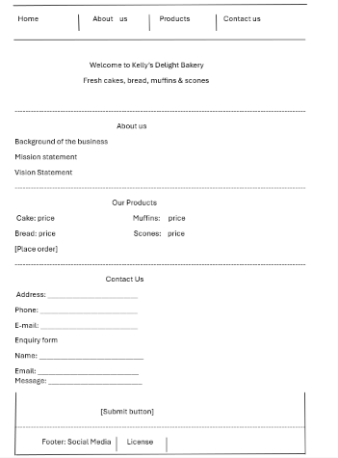

5. Technical Requirements
- Domain Name: www.kellydbakery.co.za
- Hosting: enough storage and constant backups for website safety and easy access
- Programming Languages: HTML , CSS , and JavaScript

6.Timeline and Milestone
- Week 1: Planning the website and assemble requirements
- Week 2: Create and plan wireframes including page layouts
- Week 3: Design the website using HTML, CSS, JavaScript
- Week 4: Test the website and deploy

7.Budget
Overall budget: R10000
- Website development- About R6000 to cover the cost of designing the bakery website.
- Hosting and domain- about R1500 to cover annual registering the website’s domain name
- Maintenance and updates-R2500 p/y for websites support, software updates

